Summer Camp
250.785.7070
info@simplymusic.com
www.simplymuisc.ca
we are on Facebook!
Registration Form

Parent’s Surname: Parent’s First Name(s): Today’s Date:

Home Phone: Work: Cell:

Mailing Address: Postal Code: Email:

Child’s Surname: Child’s First Name: Birthdate:

Current Age: Gender: M F Referred by:

Allergies: Name of Physician:

July 9,10, 11, 2024 (9am-12pm) JAZZ KITCHEN
August 13,14,15, 2024 (9am-12pm) CARNIVAL OF MUSIC

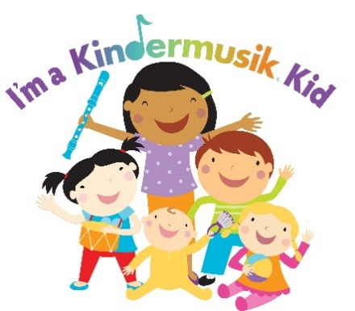
Half Day Camps

